Reseller Application

Team members:

1. Harish S S
2. Jaisri

REST API’s required:

1. GET - To get all Advertisements displayed in the home page.(On page load)

/home

Response: List of Advertisement objects

Eg:

[

{

"ad_id": "ad_id 1",

"seller_id": "seller_id 1",

"subcategory_id": "subcategory_id 1",

"category_id": "category_id 1",

"product_name": "product_name 1",

"category_name": "category_name 1",

"description": "description 1",

"price": 11,

"views": 28,

"date_posted": 1674654054,

"Image": "https://loremflickr.com/640/480",

"id": "1"

},

{

"ad_id": "ad_id 2",

"seller_id": "seller_id 2",

"subcategory_id": "subcategory_id 2",

"category_id": "category_id 2",

"product_name": "product_name 2",

"category_name": "category_name 2",

"description": "description 2",

"price": 31,

"views": 54,

"date_posted": 1674653994,

"Image": "https://loremflickr.com/640/480",

"id": "2"

}

]

1. GET - To get the general category and subcategory details of the products available to display in the filter section.

/home

Response: List of Objects

Eg:

[

{

"category_name": "Phone",

"Subcategories": [ "Apple", "Oneplus","Samsung","Vivo"],

"id": "1"

},

{

"category_name": "Laptop",

"Subcategories": ["Asus","Macbook","Lenovo","Acer"],

"id": "2"

}

]

1. GET - To get items based on category

/{category} Eg :/mobile

Response: List of Objects

Eg:

[

{

"ad_id": "ad_id 1",

"seller_id": "seller_id 1",

"subcategory_id": "subcategory_id 1",

"category_id": "category_id 1",

"product_name": "product_name 1",

"category_name": "category_name 1",

"description": "description 1",

"price": 11,

"views": 28,

"date_posted": 1674654054,

"Image": "https://loremflickr.com/640/480",

"id": "1"

},

{

"ad_id": "ad_id 2",

"seller_id": "seller_id 2",

"subcategory_id": "subcategory_id 2",

"category_id": "category_id 2",

"product_name": "product_name 2",

"category_name": "category_name 2",

"description": "description 2",

"price": 31,

"views": 54,

"date_posted": 1674653994,

"Image": "https://loremflickr.com/640/480",

"id": "2"

}

]

1. POST - To mark that the user has viewed the specific product to maintain the view count of each product.

/viewlist

Input : Advertisement_ID(Inetger),

user_ID.(Integer)

Response: Status(200) for success

Status(401) for failed.

1. POST - Login request.

Input: Username, password.

Response: status code - 200 (successful login)

* 401 (Authentication failed)

1. POST - Buy product( when the user clicks the buy button in the advertisement view)

Input: Advertisement_id, user_id

Response: Status(200) Success

Status(401) failure

1. POST - Quote an amount to a specified product

Input: User_id, Advertisement_id, quoted_amount, date

Response : Status(200) for success./ (401) for failure

1. POST - post advertisement for the product you want to sell.

Input : seller_Id, buyer_Id, category_Id, Supplier_id, Description,

Price, Minimum price(Intger), Images.(Image URI)/String

Response: Status(200) for success

1. GET - pending advertisement

Input : Id (String)

sellerId(String)

1. GET -Check minimum price amount

Input: Advertisement_id: (Integer)

Response : True/False.

1. GET - To get the purchased products or properties details by user

Input : User_id: (Integer)

/{user_id}/MyProducts

Response: List of Objects

Eg:

[

{

"ad_id": "ad_id 1",

"seller_id": "seller_id 1",

"subcategory_id": "subcategory_id 1",

"category_id": "category_id 1",

"product_name": "product_name 1",

"category_name": "category_name 1",

"description": "description 1",

"price": 11,

"views": 28,

"date_posted": 1674654054,

"Image": "https://loremflickr.com/640/480",

"id": "1"

},

{

"ad_id": "ad_id 2",

"seller_id": "seller_id 2",

"subcategory_id": "subcategory_id 2",

"category_id": "category_id 2",

"product_name": "product_name 2",

"category_name": "category_name 2",

"description": "description 2",

"price": 31,

"views": 54,

"date_posted": 1674653994,

"Image": "https://loremflickr.com/640/480",

"id": "2"

}

]

1. GET - To get the products sold by the user

Input : user_id (Integer)

/{user_id}/soldProducts

Response

[

{

"ad_id": "ad_id 1",

"seller_id": "seller_id 1",

"subcategory_id": "subcategory_id 1",

"category_id": "category_id 1",

"product_name": "product_name 1",

"category_name": "category_name 1",

"description": "description 1",

"price": 11,

"views": 28,

"date_posted": 1674654054,

"Image": "https://loremflickr.com/640/480",

"id": "1"

}, {....}]

1. GET - To get the list of advertisements that are still not purchased

Input:

Input: user_id (Integer)

/{user_id}/advertisements

Eg:

[

{

"ad_id": "ad_id 1",

"seller_id": "seller_id 1",

"subcategory_id": "subcategory_id 1",

"category_id": "category_id 1",

"product_name": "product_name 1",

"category_name": "category_name 1",

"description": "description 1",

"price": 11,

"views": 28,

"date_posted": 1674654054,

"Image": "https://loremflickr.com/640/480",

"id": "1"

}, {....}]

1. GET - to get the total views of the product when advertisement is displayed

Response: Total views(Integer) .

1. PUT - to accept the quote amount of any buyer and approving the purchase of the product.

Input: Ad_id (Integer)

Buyer_id (Integer)

Seller_id (Integer)

Final price ( Integer)

1. PUT - To update the advertisement details

Input : User Id (Integer)

Advertisement object (Advertisement class)

1. DELETE - To delete the advertisement

Input: User_id (Integer)

Advertisement object (Advertisement class)

Response:

Status: 200(success)

1. DELETE - Revoke the quote request for buying the product by the buyer.

Input : user_id(Integer)

Advertisement_id(Integer)

Response :

Status : 200(success)/ (401) Authentication failed)

1. PUT - Update the minimum price of the Advertised product

Input: user_id (Integer),

Advertisement_id ( Integer)

Minimum price (Integer)

Response:

Status : 200 (success)

1. GET - To get the top quoted amount for an advertisement

Input - ad_id (Integer)

Response :

Eg: {user_id: 101, quoted amount : 20000}

Table design:

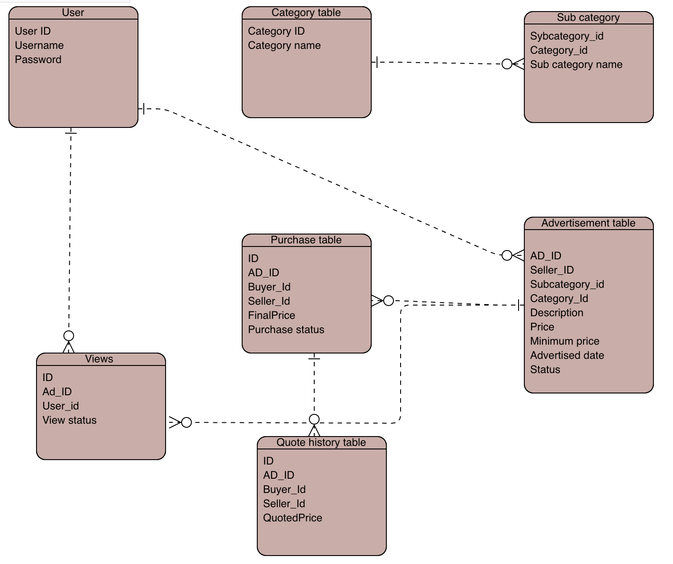

UI Screens:

Home page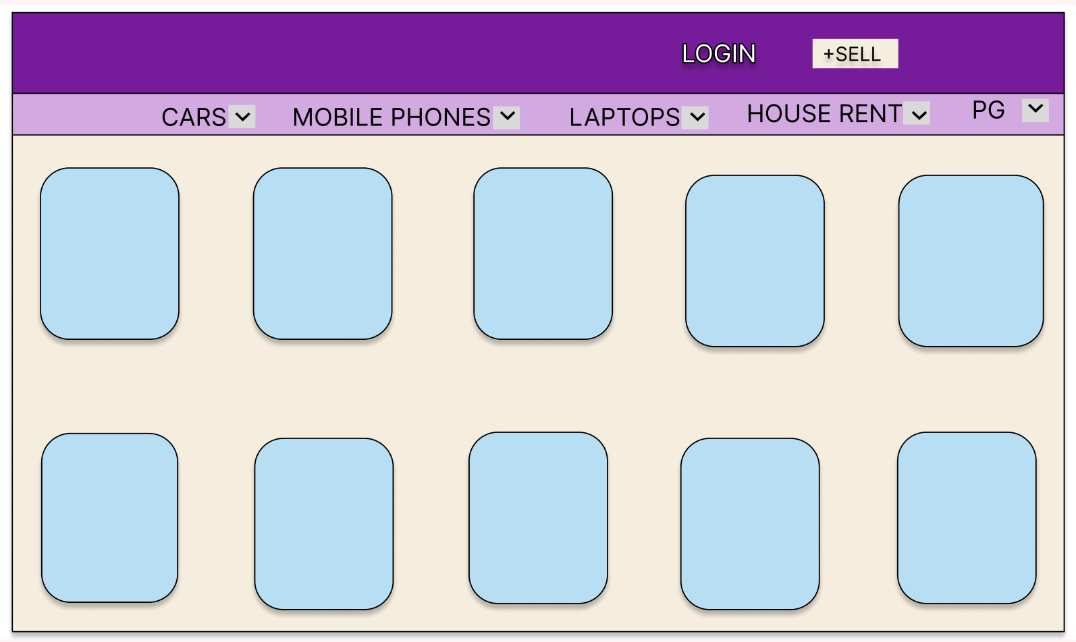

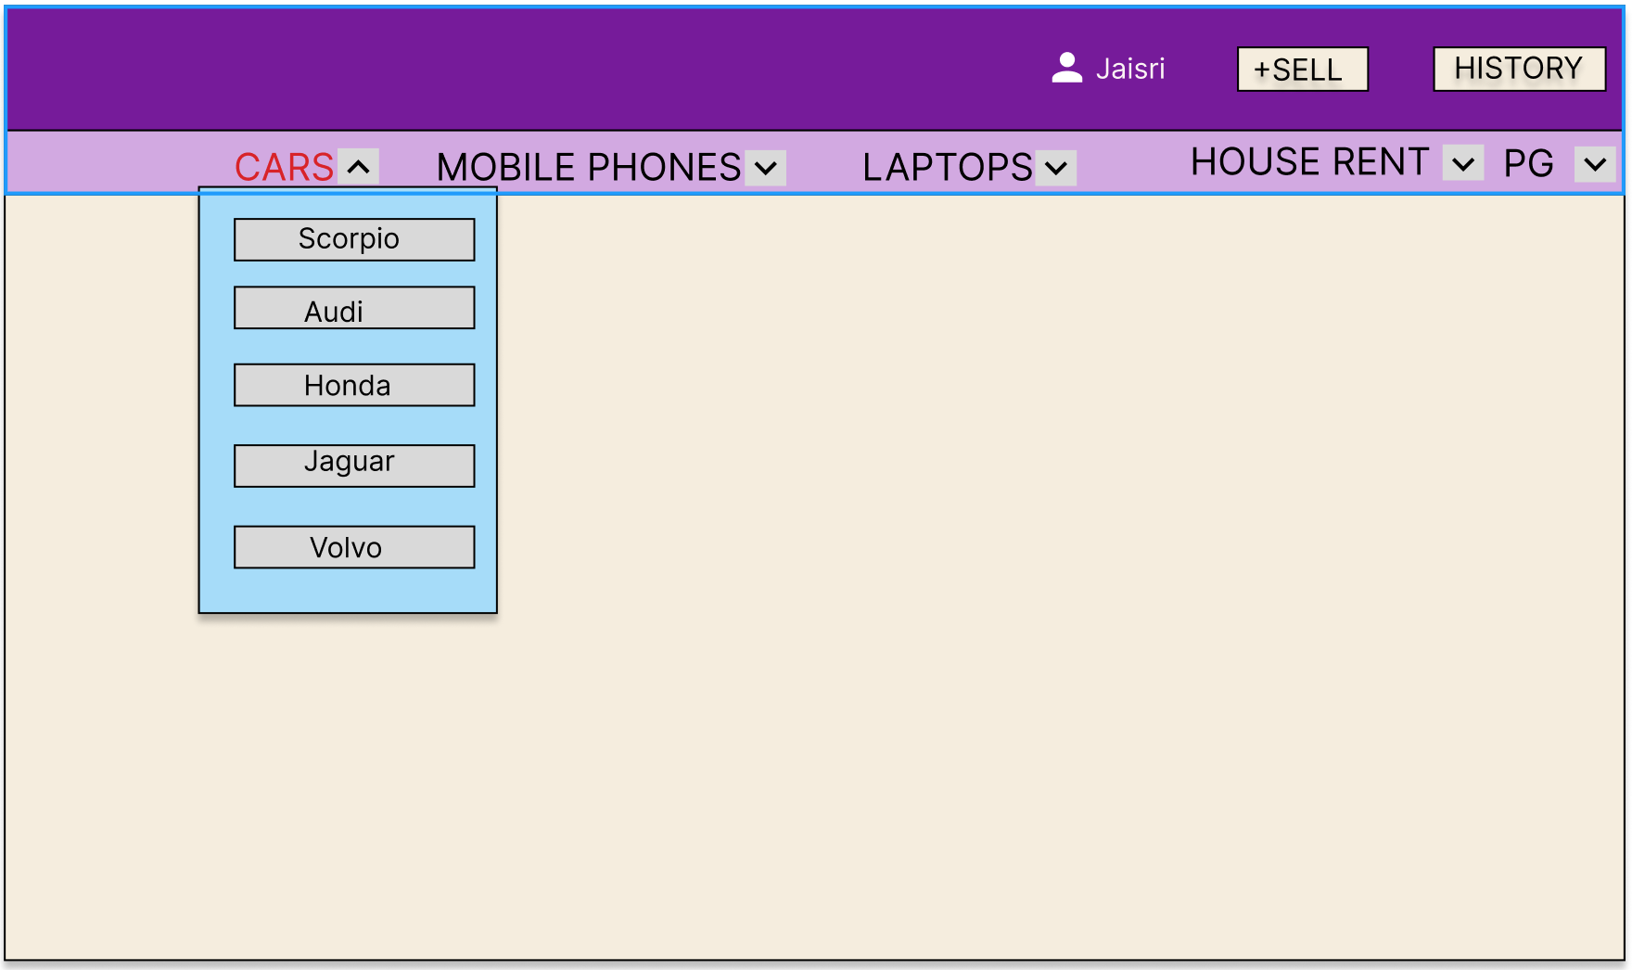

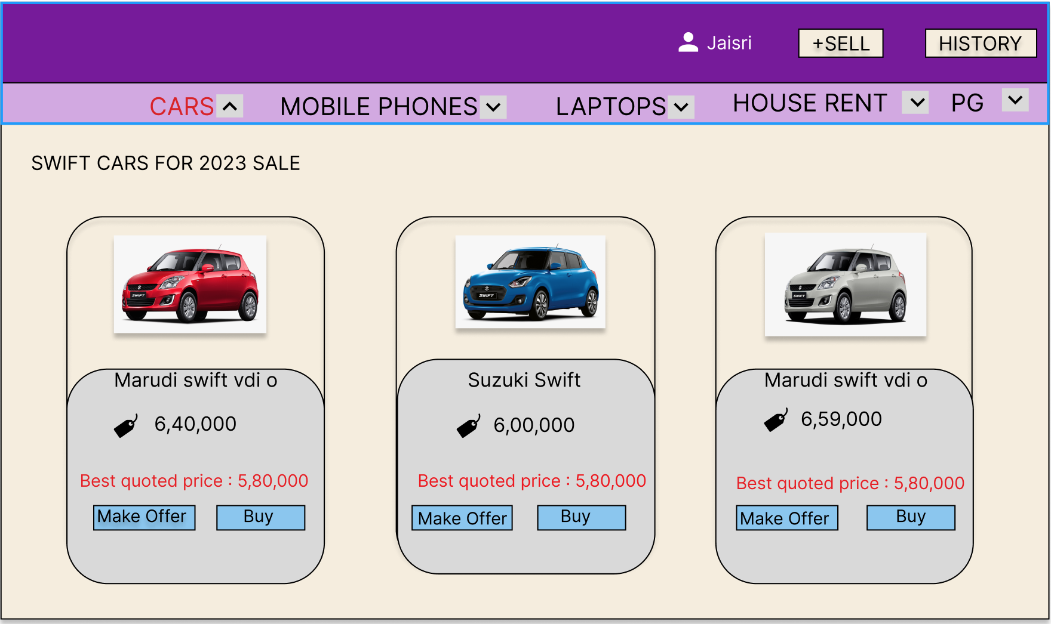

Login page:

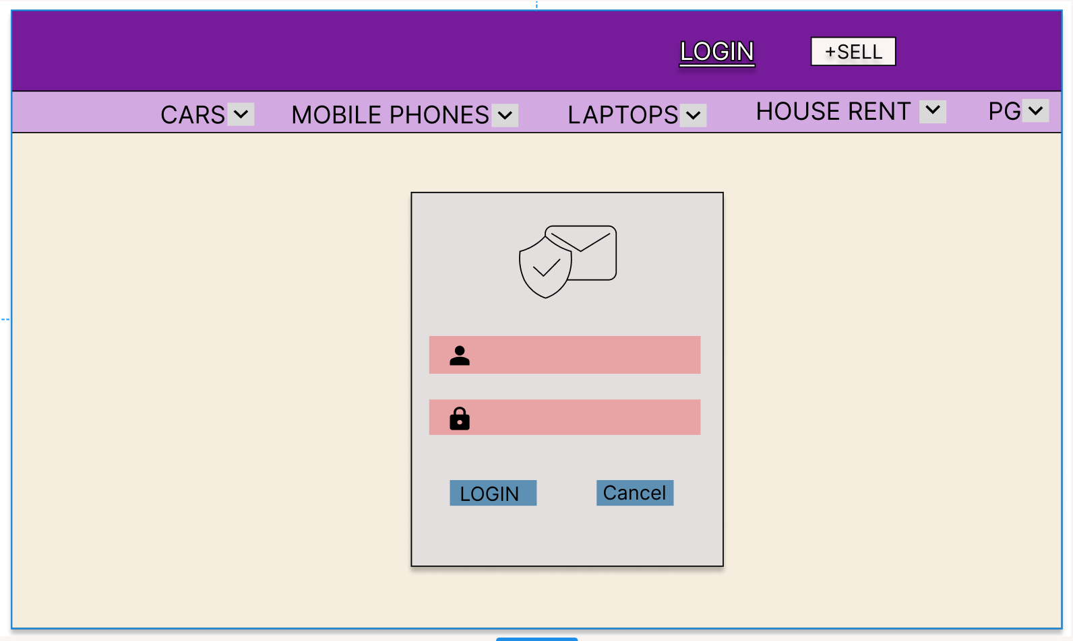

Purchase product

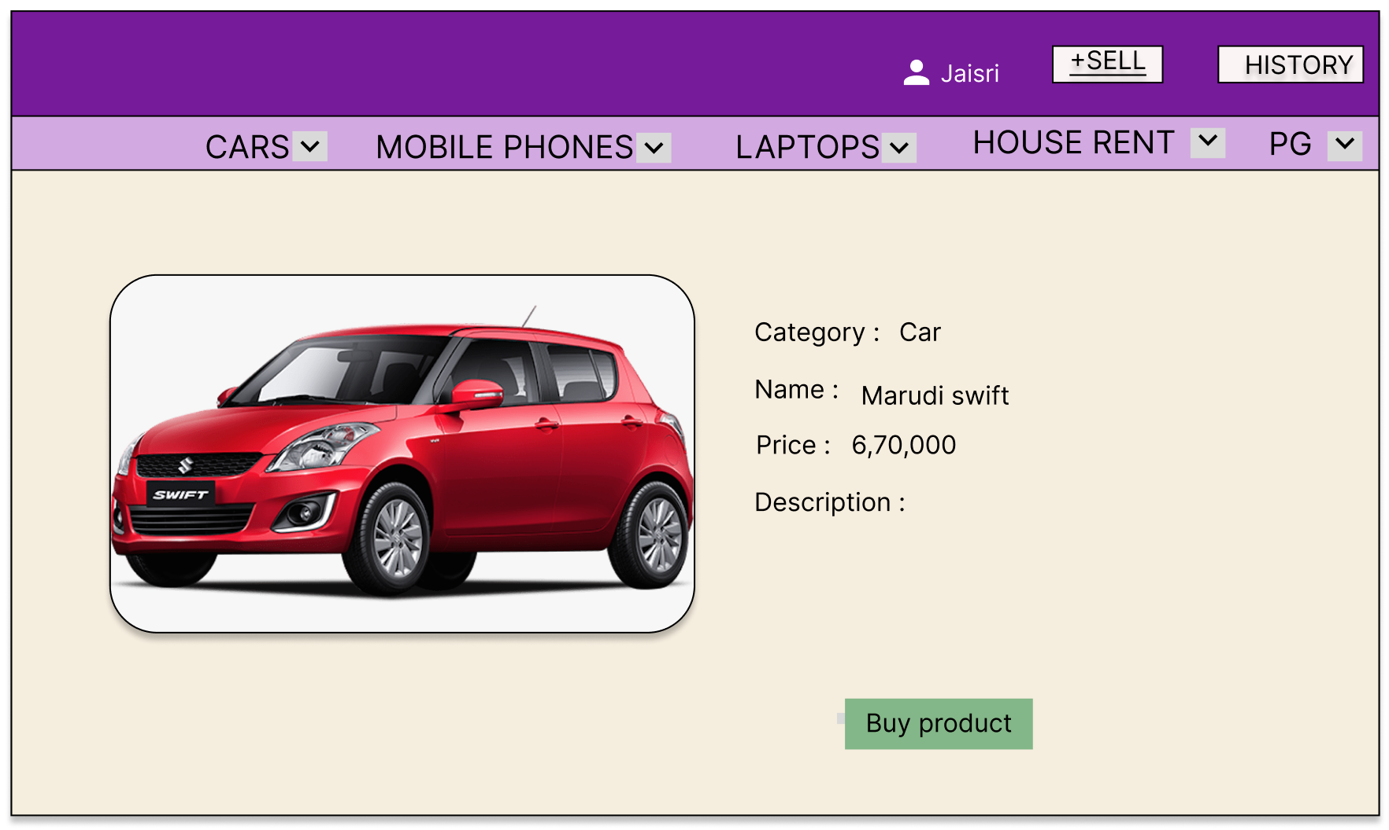

Make offer request

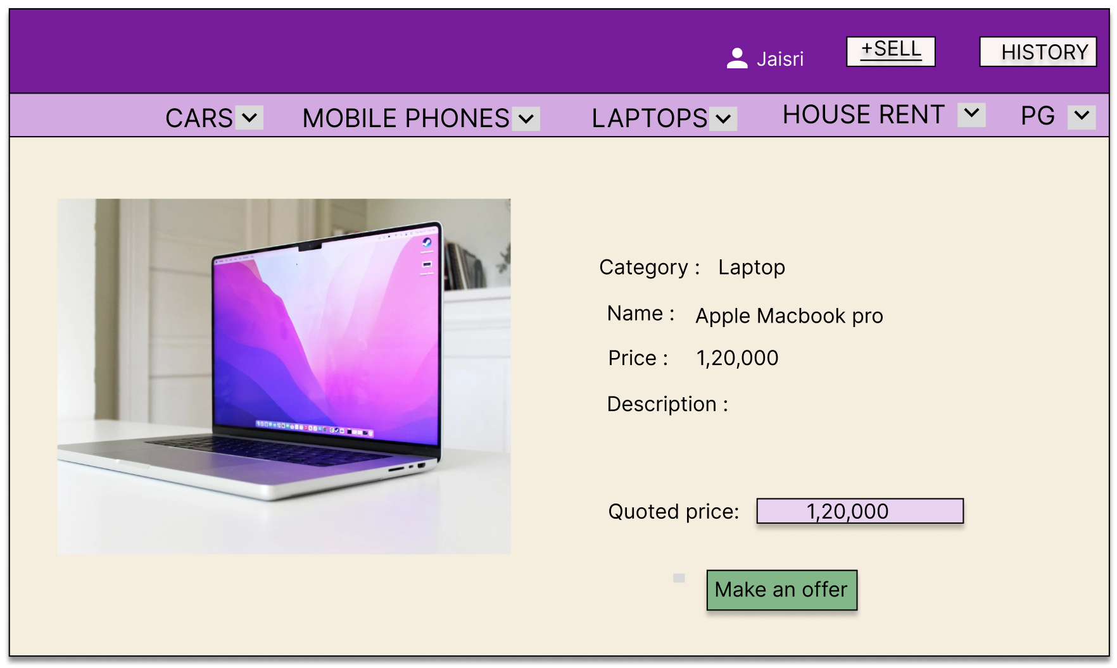

User history

